TC-CUS-007
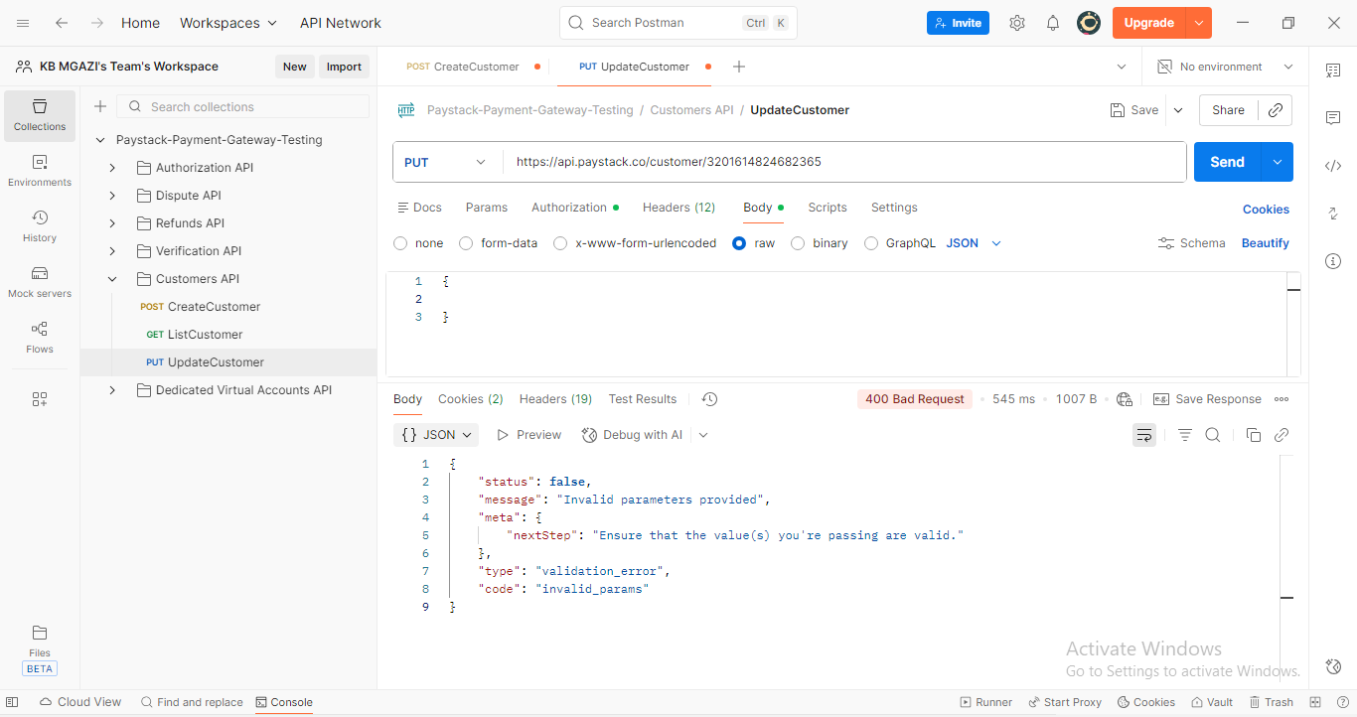
Response:
{
"status": false,
"message": "Invalid parameters provided",
"meta": {
"nextStep": "Ensure that the value(s) you're passing are valid."
},
"type": "validation_error",
"code": "invalid_params"
}

